AquaChain Production Development Plan Report
Team 1: Rachana Bangalore Nagaraju, Shruti Kalyanaraman, Mihir Kavishwar, Patrick Okimi, William Lopez
Department of Industrial and Systems Engineering
University of Southern California
ISE 585: Strategic Management of Technology and Innovation, Spring 2024
Instructor: Paul Lu
Due Date: Apr 5, 2024

Aggregate Planning
Most of our customers have smart meter sensors in place and we just provide SaaS to them. For an exception, where the utility companies do not have smart sensors, we provide the sensors from a third party sensor who are an original equipment manufacturer (OEM) and also install sensors in the network.

Demand Forecasting
- Forecasted Demand for the next year: 1000 units of water management systems

Production Capacity and Resources
- Production Capacity: 400 units per month
- Third-party company workforce for manufacturing sensors: 20 full-time employees
- Equipment: Sufficient to meet production capacity

Inventory Management
- Target Finished Goods Inventory: 2,00 units

Production Planning and Scheduling
Monthly Production Plan (From Sales Forecast)
Q1: January to March | 250
Q2: April to June | 246
Q3: July to September | 262
Q4: October to December | 242

Supply Chain Management
- Raw Material Lead Time: 1 month
- Safety Stock for Raw Materials: 20% of monthly usage
- Establish a partnership with a reliable sensor manufacturer offering industrial-grade water quality sensors with a proven track record.
- Negotiate bulk purchase agreements with the sensor manufacturer for a 10% discount.

Financial Planning and Analysis
Cost per unit :
Total Cost per Unit | $158.62

Selling price
Selling Price per Unit | $174.48

Expected Revenue
2024 | $174,480.00

Expected Production Cost
Total operating Expenses | $520,321

Expected Profit
Net Income | -$492,290.93

This aggregate plan provides a basic framework for AquaChain's production and inventory management activities over the next year. It considers forecasted demand, production capacity, inventory targets, supply chain logistics, financial analysis, risk management, and performance monitoring.

Sales and Operations Planning

Sales Forecast

Target Units
- 1000 AquaChain subscriptions with a 20% take rate for the sensor add-on.

Target Market
- Primary: Utility companies managing a minimum of 50,000 customer connections.
- Secondary: Municipalities with a population exceeding 100,000.
Competitor Analysis
- Research the top 3-5 competitors offering similar water management software.
- Analyze their market share, features, and customer base overlaps.

Sales Channels
- Direct Sales Team: 5 - 10 dedicated sales representatives focused on utility companies.
- Collaborate with 2 major water industry technology providers.
Forecasting Outputs
- Unit Sales Forecast (Year 1):
  - Primary Market: Aim for 9,000 target utilities & a 10% adoption rate.
  - Secondary Market: Aim for 1000 target municipalities & a 1% market penetration.
- Sensor Add-on Sales Forecast (Year 1):
  - Assume a 20% take rate for the sensor add-on among AquaChain subscribers.
- High and Low Forecast Scenarios:
  - High Scenario: Increase adoption rates by 5%.
  - Low Scenario: Decrease adoption rates by 1%.

Key Activities

Marketing & Sales
- Develop case studies showcasing successful AquaChain pilot deployments.
- Train the sales team to highlight AquaChain's USP.
- Identify and qualify 70 potential customers through industry events.

Pilot Deployments
- Secure 5 pilot deployments with utility companies with over 1 million customer base.
- Collaborate with partners to implement AquaChain.
- Gather feedback through user surveys with a target 80% satisfaction rate.

Product Development & Improvement
- Implement new features for leak detection and prediction using sensor data. Develop a mobile app for real-time water quality monitoring by field personnel

Customer Onboarding & Support
- Streamline onboarding, establish dedicated customer support, and conduct in-person training for key personnel.

Operations

Capacity & Capability Planning
- Scale up development efforts and infrastructure: Hire 3-5 additional software developers to support new features, upgrade server infrastructure to accommodate increased data volume, and secure a partnership with a cloud service provider for scalability.

Master Production Schedule
- Schedule sensor procurement based on confirmed customer orders, with a lead time of 2 months for sensor manufacturing and delivery.

Detailed Planning & Execution
- Create a comprehensive plan with a 4-week timeframe from the signing of the contract to the completion of system installation and training for customers.Adopt the set plan for executing deployments, aiming for a 95% on-time completion rate.
Material Requirements Planning (MRP)
The Master Production Schedule will serve as our Internal Operating Plan (IOP) to ensure that we are meeting customer demand effectively on a monthly basis.
Month | 2024 | 2025 | 2026 | 2027 | 2028 | 2029 | 2030 | 2031 | 2032 | 2033
January | 84 | 164 | 262 | 301 | 497 | 569 | 630 | 692 | 753 | 815
February | 76 | 148 | 237 | 273 | 450 | 515 | 570 | 626 | 682 | 737
March | 90 | 176 | 281 | 323 | 533 | 610 | 675 | 741 | 807 | 873
April | 96 | 187 | 300 | 344 | 568 | 650 | 721 | 791 | 861 | 931
May | 80 | 156 | 250 | 287 | 474 | 542 | 600 | 659 | 718 | 776
June | 70 | 137 | 218 | 251 | 414 | 474 | 525 | 577 | 628 | 679
July | 86 | 168 | 268 | 309 | 509 | 582 | 645 | 708 | 771 | 834
August | 96 | 187 | 300 | 344 | 568 | 650 | 721 | 791 | 861 | 931
September | 80 | 156 | 250 | 287 | 474 | 542 | 600 | 659 | 718 | 776
October | 76 | 148 | 237 | 273 | 450 | 515 | 570 | 626 | 682 | 737
November | 86 | 168 | 268 | 309 | 509 | 582 | 645 | 708 | 771 | 834
December | 80 | 156 | 250 | 287 | 474 | 542 | 600 | 659 | 718 | 776
Total Units | 1,000 | 1,950 | 3,120 | 3,588 | 5,920 | 6,773 | 7,505 | 8,238 | 8,970 | 9,702

This BOM will be used in the event that our customer is not equipped with the proper hardware and we may have to serve as the final integrator between the smart meter’s various subassemblies and components.

Enterprise Resource Planning (ERP)
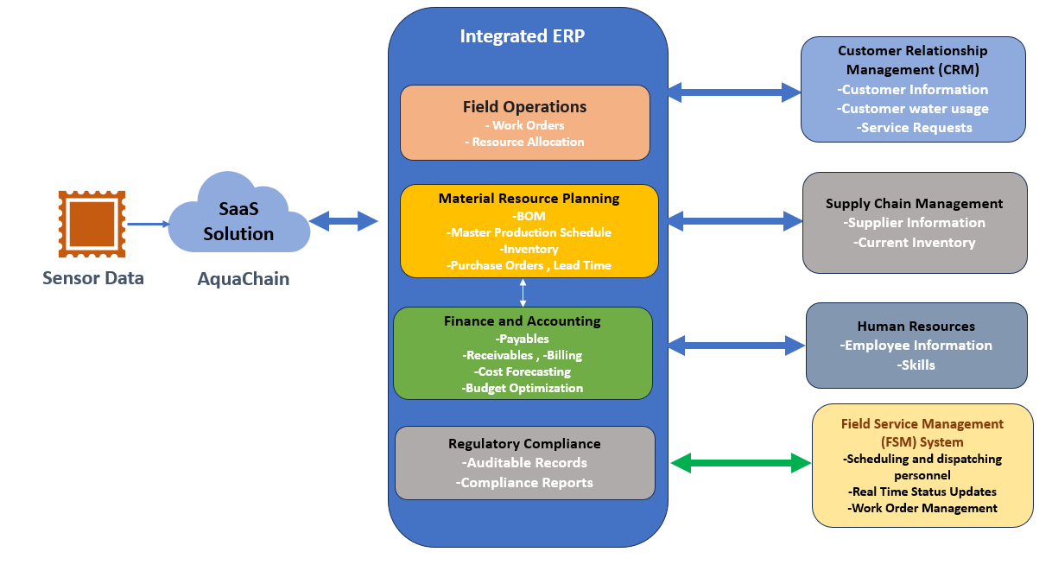

Architecture Overview
The model integrates with AquaChain's cloud-based platform, which collects real-time water quality and usage data from deployed IoT sensors. This data is then disseminated to relevant departments within the ERP system, Customer Relationship Management (CRM),Supply Chain Management(SCM) and Field Service Management(FSM) enabling informed decision-making, optimized resource allocation, and enhanced water management practices.

System Components and Data Flow

AquaChain Platform (Cloud-Based):
    - Function: Captures and analyzes water quality and usage data.
    - Data Flow: Sends analyzed data and alerts to relevant ERP modules.

Integrated ERP System:
  - Field Operations:
    - Function: Manages maintenance tasks based on sensor data.
    - Data Flow: Receives work orders and sends updates to FSM.
  - Inventory Management (within MRP):
    - Function: Tracks inventory levels and facilitates purchase orders.
    - Data Flow: Receives real-time inventory data and sends purchase order requests to SCM.
  - Material Requirements Planning (MRP):
    - Function: Calculates material needs for water maintenance.
    - Data Flow: Receives inventory and usage data, sends purchase order requests to SCM.
  - Finance & Accounting:
    - Function: Manages financial aspects and optimizes budgets.
    - Data Flow: Receives projected costs and invoices, sends budget constraints.
  - Regulatory Compliance:
    - Function: Maintains auditable records for compliance.
    - Data Flow: Receives water quality data.

Other Connected Systems:
  - CRM:
    - Function: Handles customer billing and water conservation.
    - Data Flow: Receives usage data, sends invoices and conservation campaigns.
  - SCM:
    - Function: Manages procurement of materials.
    - Data Flow: Receives purchase orders, tracks orders, and manages inventory.
  - FSM:
    - Function: Optimizes scheduling and dispatch.
    - Data Flow: Receives service requests, dispatches technicians, and updates work orders.
  - Human Resources:
    - Function: Organizes employee data, ensures regulatory compliance, and facilitates resource allocation.
    - Data Flow: Receives updates on employee skills, maintains a database, and transmits relevant technician data to Field Operations.

Communication Protocol: We utilize APIs: Mulesoft for secure data exchange between modules
Benefits of ERP : Based on reports and insights, informed decisions are made across departments. Actions are taken to optimize water management, resource allocation, customer service, regulatory compliance, and supply chain efficiency.

Short Term Planning
The purpose of this short-term production plan is to outline the objectives and strategies for producing AquaChain units over the next year. This plan aims to ensure efficient resource allocation, timely production, and responsiveness to market demands. AquaChain’s short term plan for the next year is presented in the AquaChain Short Term Planning Table.

The short-term production plan for AquaChain is structured to meet monthly production targets effectively while ensuring timely delivery and meeting market demand. Key resource allocation strategies focus on software development and supply chain management. Skilled developers are dedicated to tasks such as maintenance, feature implementation, and performance optimization, ensuring continuous improvement of AquaChain's functionality. Additionally, strategic coordination with suppliers is prioritized to secure timely procurement of components and maintain an efficient supply chain, thus minimizing production delays. Augmentation considerations include the potential utilization of temporary workers for assembly tasks, particularly during periods of increased demand, to ensure smooth production flow and meet targets efficiently. Worker numbers are continuously monitored and adjusted to align with production demands and workload fluctuations, optimizing resource utilization.

